**Project : Toggle Led Using Push Button**

In this project, we will toggle the status of the two LED’s according to the input from a button switch. The only difference is in the programming part. And the working of the circuit is also slightly different. Every time when the controller receives input from the switch,  it will toggle the current status of the two LED’s.

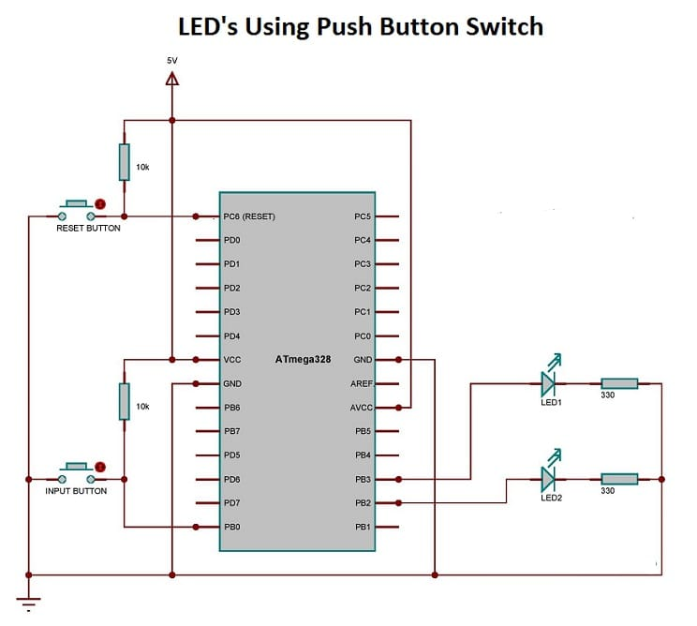

***Toggle 2 LED’s Using Push Button Switch – Circuit Diagram***

Assemble the circuit as shown in diagram. A video demonstration of the project is shown below.

<iframe width=”560″ height=”315″ src=”https://www.youtube.com/embed/A5xJcSJrl9s” frameborder=”0″ allowfullscreen></iframe>

Similar to the above sections, here also we included the pre-processors and libraries. And the necessary pins are configured as input and output  using the DDRx (Data Direction Register). An “if” loop is then included at the main program with a condition “!(PINB&(1<<PINB0))”, which will continuously monitor the status of the PB0 pin.

“PORTB ^= (1<<PINB2)^(1<<PINB3)” is the instruction for toggling the current status of the PB2 and PB3 pins. A 300 ms delay is also included at the end of the program in order to avoid debounce of the push button switch.

#define F_CPU 1000000UL

#include <avr/io.h>

#include <util/delay.h>

int main(void)

{

DDRB |= (1 << DDB2)|(1<<DDB3);

DDRB &= ~(1 << DDB0);

while (1)

{

if (!(PINB&(1<<PINB0)))

{

PORTB ^= (1<<PINB2)^(1<<PINB3);

_delay_ms(300);

}

}

}